[ IN-SERVICE TRAINING SUMMARY REPORT ]

IDC30BT

Compiled by MOTHA LP

2018

Table of Contents

INTRODUCTION 2

PREPARATION OF EXPO [ASP.net Project Presentation] 3

INTRODUCTION TO BASIC HTML/PHP 4

SYSTEM ANALYSIS AND DESIGN 5

USING GITHUB 6

PHP [MVC Concept] 7

IMPLEMENTATION OF MOBILE APP [Android Mobile App] 8

CONCLUSION 9

# INTRODUCTION

During my training course, I was refining my ASP.net application and I was introduced to other makeup and backend languages such as HTML,PHP,CSS,JAVA. I was able to implement my ASP.net application using basic HTML/PHP and I went further to implement it on a Multilayer Concept using MVC pattern. I was able to develop an android app

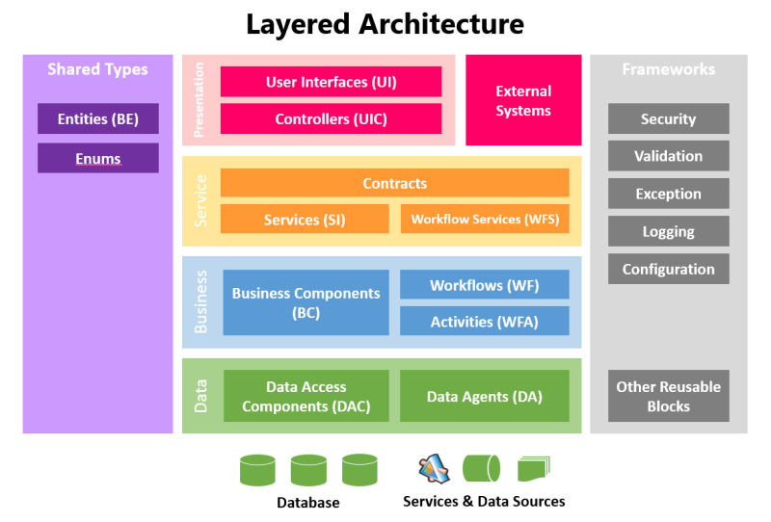

***Figure 1.Multilayered Software Architecture***

# PREPARATION OF EXPO [ASP.net Project Presentation]

I have learnt to refine an existing system which was more of software maintenance where I was focusing on the overall software usability and general system logic that defines critical business task. Very important, considering end users as far as in most cases an application is developed for end users. I have also learnt that it is important to follow the principle of good design which is visibility, availability, usability etc. I have lent ASP.net app deployment on 3-tier which is DATA ACCESS (DB Server)->HOST(Web Server)->WEB(End-User)

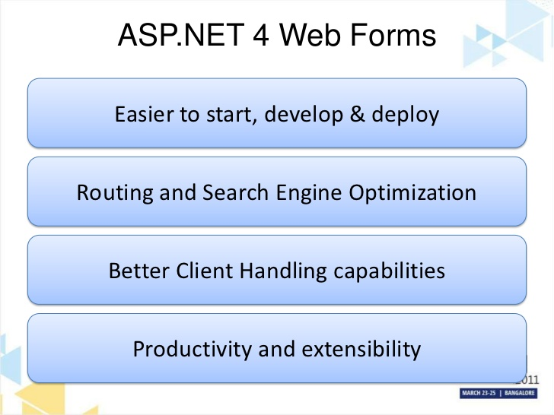

***Figure 2.Multilayered Software Architecture***

# INTRODUCTION TO BASIC HTML/PHP

On the introduction to PHP, I have learnt about different PHP editors, IDEs, database servers that are supported on PHP makeup language and how to install and setup those tools and get to use them. I also learned similarity of PHP to other languages and how to PHP defers from other languages which include declaration of variables, using if statement to compare, using loops rapidly execute codes, creating and calling functions. I have used multi language including PHP, CSS, bootstrap and JavaScript to simulate a starting system

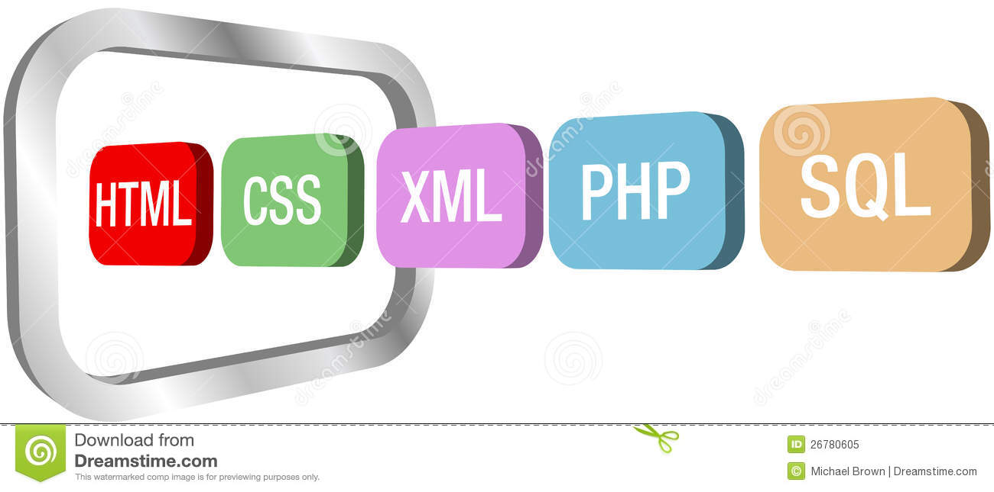

***Figure 3.HTML/PHP()***

# SYSTEM ANALYSIS AND DESIGN

We were revising the chapters of “Information Systems” (Analysis and Design) and we were required to analyse and design the system using UML Models. I have learnt that after a request, it is basically important to so as to come out with a concept of what you can then do rather than just doing it out of your opinion Ie: Think(analyse)->Visualise(concept)->Act(implement). Models help ease out pointing areas that need attention and or further discussions.

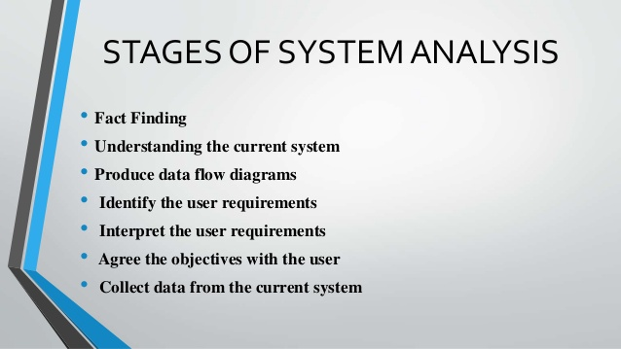

***Figure 4.Analysis***

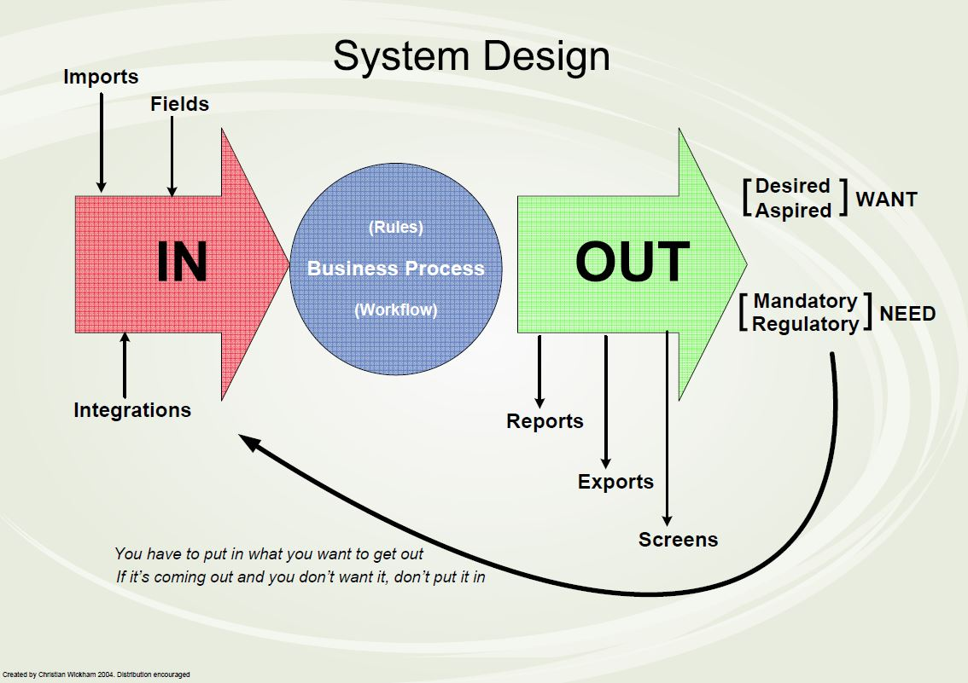

***Figure 4.Design***

# USING GITHUB



***Figure 4.GITHUB***

***Github****- is a website and service that allows developers to store their projects and network with like-minded people.*

*We created an account on Gitbhub and we used it to upload our work*

A repository (usually abbreviated to “repo”) is a location where all the files for a particular project are stored. Each project has its own repo, and you can access it with a unique URL

# PHP [MVC Concept]

On my PHP (MVC patterns) I went through the basic principles of MVC and quick examples of MVC in PHP. I went through the components of MVC which is the View, Model, and Controller and their functionality. I learned how to classes and methods using the PHP MVC framework, Calling class methods within the class itself and on other classes, I also learned how to pass a variable from controller to view or from model to view, I learned how does MVC interacts with the database, which databases supports PHP MVC how to connect to the database

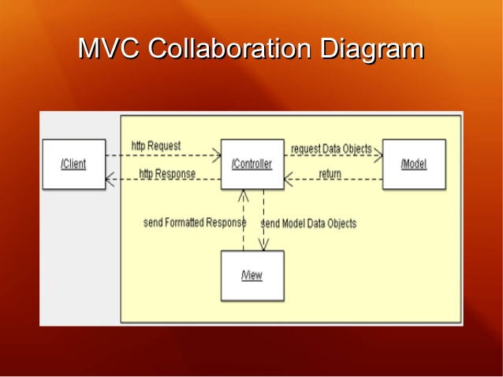

***Figure 5.PHP/MVC Pattern***

***Figure 5 shows the basic concept of PHP/MVC where:***

***Model*-***Business and app logic of the application*

***View*-***UI screens for input and/or output*

***Controller-****bridge that links the view and the model*

***More Important,* *MVC pattern addresses the issue of security concerns since information-flow from end users to the DB management systems is not accessed directly, it goes via multiple layers in which errors and exceptions may be caught an thrown back to the end user before actual data on the DB is affected***

# IMPLEMENTATION OF MOBILE APP [Android Mobile App]

I have learnt how to create a mobile app using android studio, I have created an App “Budgetory” to manage budget on my phone. I was exposed to JAVA language as we were using JAVA.

# CONCLUSION

I have learnt that working in groups in stressful especially when other group members doesn’t commit to the work at hand or when they don’t possess maximum effort to the entirely work

I have gained experience in changing from one language to another. I have also got experience in working as a team which joins efforts of multiple members to produce a quality application. I have learnt to collaborate with other group in discussing issues and challenges that we face as an entire class

In general I have gained minimum skills that to myself serve as a foundation that I can build upon in a work place. I went through multiple conflict and I was able to handle it which also gives a minimum experience in conflict management and resolution. I have also gained persuasion and influencing skills as well as facilitation skills, most of all I got was communication skills